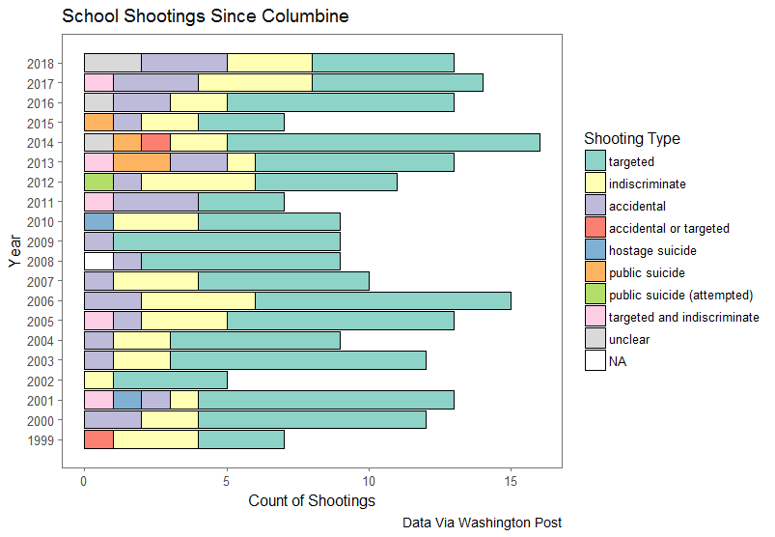Though it was not the first of its kind (see ‘I don’t like Mondays girl’), the shooting at Columbine High School in 1999 marked a watershed moment for American K-12 education. School shootings have been a persistent feature of American public education since then; such events captivate the national media and public discourse, though often only for brief periods of time (citation). Much research and public discussion has focused on theoretical causes of such incidents, with variable focuses on media and popular culture (e.g., violent video games and music), the availability of guns, bullying in schools, and adolescent mental health. Schools reacted by implementing metal detectors and increasing police presence, though this response was racially disparate (citation?). The main line of research and discourse has operated on the assumption that identifying the causes of such incidents can allow schools and policymakers to implement reduce their frequency. For example (insert section on Virginia Threat Assessment here, cf. Cornell)

Since the shooting at Columbine High School in April of 1999, the frequency of such shootings has remained roughly constant, with about 11 (plus or minus 3) such incidents per year. In fact, this year, at the time of writing of this literature review, there have already been 13 such incidents, indicating that 2018 may be an outlier year for the phenomenon. The data suggest that rather than being an *increasing* trend, as perhaps portrayed in the media, nor a trend *reduced* by improvements in public policy and school safety measures, school shootings are a consistent fact of life in American PK-12 education which must be considered on those terms. Unless and until they can be reduced in number and severity, policy must be created around how schools and communities can react to them to mitigate their effects.

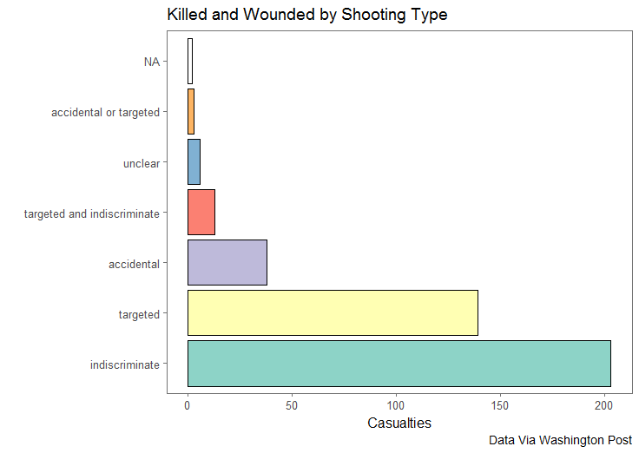The data suggest that such shootings happen at all grade levels, with elementary schools represented (e.g. Buell Elementary School in 2000, when a six year old targeted and killed an individual at his school with a handgun) as well as shootings in post-secondary education such as the Virginia Tech incident in April, 2007. The greatest number of these incidents are targeted killings of other individuals within the school; however, the greatest number of casualties, and the greatest cultural impact, come from indiscriminate killings with no apparent targets other than the school community itself. As such, some school shootings can be considered to be a kind of community trauma, impacting more than just those students who are physically victimized but also myriad school and community members who will experience varying levels of post-traumatic stress and psychological and mental health needs as a result of the incident. It is on these terms that this paper will review the literature: how much is known about the extent of psychological trauma experienced by those who survive incidents of school violence or crisis, and what programs and policies have been studied which attempt to lessen the impact of such events? Moreover, how do school districts attempt to resume normal operations of schooling and community functioning in the wake of such incidents?

|  |  |  |  |
| --- | --- | --- | --- |
| **Sections by Order** | | | |
|  | **All trauma** | **Community trauma** | **School shootings** |
| **Prevention** | **X** | **X** | **(1) (short)** |
| **Effects** | **(2) (short)** | **(3) (longer)** | **(4) (full)** |
| **Programming** | **(5) (very short)** | **(6) (longer)** | **(7) (longest)** |

**The Size and Shape of the Impact**

**Impacts of trauma on children in general**

* **Nadu (2006)**
* **Tosone (2012)**
* **Burnham (2012)**
* **Pine (2015)**
* **Carlson (year?)**
* **Impact on schooling**
  + **Bowen and bowen 1999**
  + **Delaney black et al 2002**
  + **Hurt et al. 2001**
  + **Schwartz and Gorman 2003**
* **Impact on mental health**
  + **Ayer et al (2017)**
    - Externalizing bx in kids exposed to violence
    - Some portion of students were low, some were high, and some were high but improved
    - Demographic differences
    - Externalization predicted by family level factors and baseline internalizing

**What there is on impact of school shootings specifically**

* Strom 2016
* Liao 2015
* Murtonen (2011) & Suomalainen (2011) and Dyb (2014; post traumatic stress reactions)
* Nurmi (2011)
* Charuvastra, 2010

**Programs which Exist**

**Programs for trauma in general**

* **Hickman et al. (2013) meta-analysis**
  + 9 studies of Safe-Start Promising Approaches
  + No significant differences in any of the studies (ITT)
  + Except child cooperation and socio-emotional competence
* Cook-Cottone
* Dyregrov
* Openshaw 2011
* Guzder 2011
* Kataoaka 2012
* Ramirez 2013
* **asdf**

**Programs for community trauma**

* Prinstein
* Openshaw 2013
* Dyregrov 2015
* Jimerson 2005
* Spokane
* Zachariah 2012
* Bhadra 2012
* Ng 2014
* Mutch 2015
* Blanc 2015
* Shultz 2015
* Mutch 2016
* Saddiqui 2017

**Response to school shootings?**

* **Charuvastra**
* **Crepeau-Hobson 2011**
* **Dishman**
* **Crepeau-Hobson 2012**
* **Dyb 2014 (early outreach)**
* **Paine (n.d.)**

**Preparedness?**

* **Graham 2006**
* **Weisbrot 2008 (maybe… if there’s time)**

**(Follow the money)**